

Penn Skates
Summer Camp



2013

Penn Skates
2210 High Tech Road
State College, PA 16803
Website: www.pennskates.com
Email: vdench@pennskates.com
Phone: 814-357-6898
Fax: 814-357-6897
Parent Handbook


2210 High Tech Road, State College, PA 16803 * (814) 357-6898 * Fax (814) 357-6897
www.pennskates.com

Dear Summer Camp Parents,
Welcome to our 2013 Summer Day Camp program! Your child(ren) will have the opportunity to participate in a variety of planned recreation ranging from outdoor and indoor activities, sports, arts and crafts, group activities, guest speakers, themed days, and a field trip every week!
Attached to this is the information about our Summer Camp. Please read through the entire Parent Handbook for detailed camp information. For information about specific events/activities, times and locations, please be sure to read our Weekly Camp Newsletter that will be distributed to all parents every Friday for the following week. If you have any other questions feel free to ask our helpful staff members or email Valerie Dench (vdench@pennskates.com).
We can ensure that your child(ren) will have a fun and safe summer participating in our program. We have created a calendar with themed days and field trips that your child(ren) will enjoy. If at any time you as a parent/guardian are interested in assisting with certain activities or providing supervision or transportation for a field trip please feel free to contact us in advance.
A few reminders for the summer program:
Camp runs from June 10 through August 30 (Mondays-Fridays), from 7:30 a.m. – 5:30 p.m. at Penn Skates. Your child can attend the whole week or just a few days each week. Lunches are not provided, but you can buy lunches at Penn Skates. Snack will be provided, extra snacks can be bought through a weekly tab.
If you have any questions please feel free to call Penn Skates or email Valerie Dench at vdench@pennskates.com. Thanks again for registering for Summer Day Camp!
Sincerely,

Penn Skates Summer Camp
2013
“Believe in yourself and everything is possible.”
Our staff is very excited and looking forward to a wonderful year. This handbook contains Penn Skates Summer Camp policies and procedures, which are important to you and your child. By signing the following, you agree to follow the policies, procedures and practices placed before you within the Penn Skates Summer Camp Handbook.

Name of Child___________________________ ___________________________

Name of Parent (s) _______________________ Start Date ___________________

Signature _______________________________ Date _______________________

Please remember to notify Penn Skates Summer Camp if your child will be absent.

Financial Policy: If outside assistance is required to collect any outstanding balances on your account, all costs incurred, including any and all attorney fees, collection fees, and/or court costs will be added to your account.

I understand Penn Skates Summer Camp’s Financial Policy __________.
Initial

2210 High Tech Road
Office: 814-357-6898
Fax: 814-357-6897
Email: vdench@pennskates.com
Web Address: www.pennskates.com

General Policies and Procedures

Personal Property:
Cell phones, iPods, handheld video games and all other electronic equipment are not allowed, for any reason, at the camp facility. All other personal property must have your child’s name on it. Penn skates Summer Camp is not responsible for damaged, lost or stolen items, to include items that are left overnight.

Clothes:
Children should wear sneakers, with socks, everyday (unless otherwise specified on trip days). Clothing should be weather appropriate and children should BRING A BATHING SUIT TO PENN SKATES SUMMER CAMP EACH DAY and bring a towel (water activities will be available on most days.)

Sun Protection:
Please put sun protection on your child prior to coming to Penn Skates Summer Camp (SPF 30 recommended). We also ask that you pack (labeled) sun protection with your child to be reapplied as necessary.

Lost and Found:
Lost and found items are displayed near the front door every day. These items will be kept for a short period of time before being donated. ***Please remember it is important to have all items labeled with your child’s name.

Schedule:
Summer camp will follow the same basic schedule every day except for Field Trip Days, schedule may change due to weather conditions and other conflicts:

Camp Hours: 7:30 am – 5:30 pm
Drop Off: 7:30 am – 9:00 am
Activity 1: 9:15 am – 10:30 am
Snack Break: 10:30 am – 10:45 am
Activity 2: 10:45 am – 12:00 pm
Lunch: 12:15 pm – 1:00 pm
Activity 3: 1:00 pm – 2:15 pm
Theme Activity: 2:15 pm – 3:30 pm
Snack Break: 3:30 pm – 3:45 pm
Free Play: 3:45 pm – 5:00 pm
Activity 4: 4:00 pm – 5:00 pm
Pick-Up Time: 4:00 pm – 5:30 pm

Sign In and Out:
All children must be signed in and out at the main desk. Parents/guardians must show their photo ID when picking up their child. No child will be released without a photo ID. Remember to notify Penn Skates Summer Camp if someone other than yourself will be picking up your child(ren). They will also need to show a photo ID.

Drop Off Procedure:
Children must be walked into the building. Parents or authorized individuals should sign each child in. At no time should you drop you child off at the front door. When picking up your child you must come in and sign your child out at the front desk. This is for the safety of your child(ren).

Lunch:
Penn Skates Summer Camp is a peanut free facility. Due to the severe allergic reaction of some of our children. ALL PEANUT products are prohibited. Lunch is not included in the weekly fee, but lunch will be available for purchase daily. Your child should bring a bag lunch. Lunches will not be available for purchase on field trip days. On trip days your child must bring a bag lunch including a drink, no glass. The lunch menu will vary and will include items from our snack bar area. A drink will always be served with Penn Skates Summer Camp provided lunches. Menus are available upon request.

Snacks:
Morning and afternoon snacks are included in your weekly fees. Additional snacks are available at our snack bar area. We recommend that parents pay for their child’s snack at the beginning of each week. Pre-paid snack money will be kept in a “bank” and a snack log will be maintained for each individual. Penn Skates Summer Camp will not be responsible for lost or stolen money if a child keeps his/her own money.

Discipline Policy:
The Penn Skates Summer Camp Director reserves the right to suspend or expel a camper at any time due to misbehavior. A Zero Tolerance policy is in effect for any child who demonstrates conduct that could cause themselves, another child or staff member harm. Vulgar Language will not be tolerated. Disrespect toward another child or staff member will not be allowed. A staff member will call or personally speak to a parent/guardian when their child demonstrates misconduct. In-camp consequences include time-out or loss of participation in selected camp activities.

Financial Policies:
There is a non-refundable registration fee of $50 per child. No credit or refunds are given for absences. Payment is expected for days registered that are not attended except due to serious illness. If you know your child cannot attend a date registered, one (1) week’s notice is required to avoid charges.
Make checks payable to: Penn Skates Summer Camp
Payment is due the Monday prior to the week you are attending:
Summer Camp Payment Schedule
If Your Child Is Registered For Camp This Week | Payment Is Due On This Date
6/10/13 | 6/3/13
6/17/13 | 6/10/13
6/24/13 | 6/17/13
7/1/13 | 6/24/13
7/8/13 | 7/1/13
7/15/13 | 7/8/13
7/22/13 | 7/15/13
7/29/13 | 7/22/13
8/5/13 | 7/29/13
8/12/13 | 8/5/13
8/19/13 | 8/12/13
8/26/13 | 8/19/13
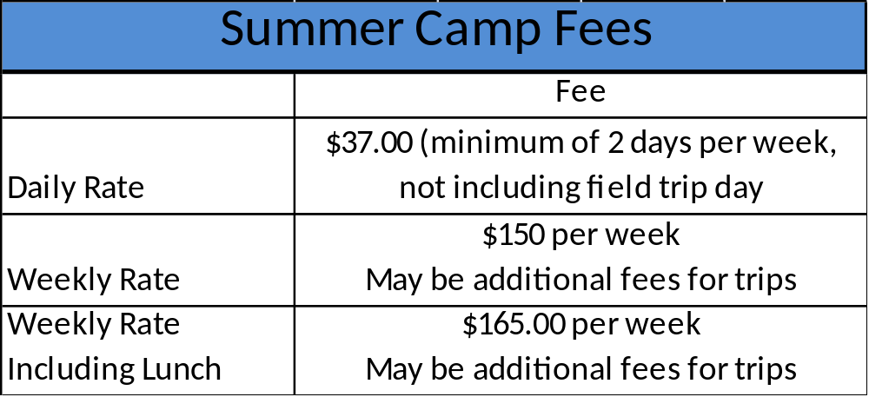

*** To attend the weekly field trip day, your child must be registered for a full week!***

Late Pick Up Fees:

There will be a late fee if your child is picked up after 6:00 pm. This fee must be made at the time of the late pick up on the day applicable.
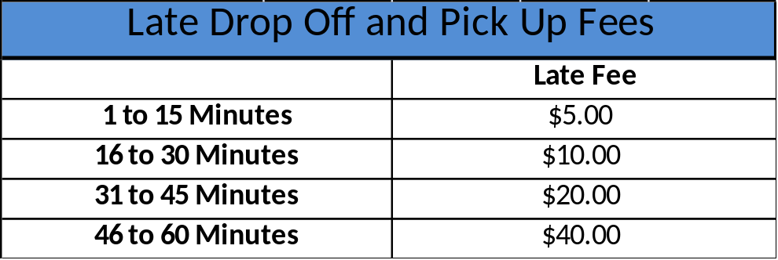

Trips:
Please make sure that your child has sunscreen applied prior to arriving to Penn Skates Summer Camp. Also, please provide all needed items listed so they can have an enjoyable day. Due to unforeseen circumstances, it is strongly suggested that you call Penn Skates before picking up your child(ren) on trip days to be sure that we will be returning as scheduled. Penn Skates reserves the right to change a trip location without prior notice to parent or guardian. Changes will be made due to weather, availability, or safety concerns. Penn Skates also reserves the right to change any daily activity, Monday-Friday as it deems appropriate for the benefit of your child(ren) – this may include the transporting of your child(ren) to an off-site location for an unscheduled field trip. It is imperative that your child arrive each day by 9:00 am except where indicated differently.
- Buses should return to camp no later than 5:30 pm
- Phone number to reach us is 814-357-6898
- Must sign and return the attached permission slip

Medication and Illness:
Penn Skates is not permitted and cannot administer medication of ANY kind under ANY circumstance. If your child(ren) is in need of medication they must be able to administer it themselves. This includes asthma inhalers and epi-pens. Please do not send your child(ren) to camp if he/she is sick. Please notify Penn Skates Summer Camp if your child(ren) is unable to attend camp on a day due to illness. If your child becomes ill at camp, we will notify you to pick up the child immediately. The camp staff must consider the well-being of every child. If your child is sent home with a communicable disease (something that is contagious), he/she may not return to camp without a written note from a doctor. (Disease examples may include: pink eye, strep, fever, diarrhea, unexplainable rashes, ringworm, etc.)

Emergency Procedures and Injuries:
All Penn Skates staff are trained on the proper emergency evacuation procedures in the event of a fire, severe weather, or other emergency. It is VERY important that Penn Skates Summer Camp staff are made aware of any change in home or emergency telephone numbers, or if there is a change in the child’s health information. Penn Skates Staff are certified and trained in CPR/AED and first aid. The staff will take all necessary precautions to prevent any health risks to campers. In the event of an injury certified staff will administer first aid, and the parent will be notified of the incident at the end of the day unless the injury requires immediate notification.

Summer Camp Registration
Please fill out this form in full. The information you provide here will be processed prior to your arrival at our facility. Please submit one form per child.
Child’s Name:
Gender: Male Female
Age:
Birth Date:
Grade Fall 2013:
Parents’ Names:

Address:
City:
State:
Zip Code:
Home Phone:
Cell Phone:
Work Phone:
Email Address:
How did you hear about camp?

People allowed to pick up your child:
Name Phone
Name Phone
Name Phone

T-Shirt Size: Youth 6-8 Youth 10-12 Youth 18-20
Adult Small Adult Medium Adult Large Adult XLarge

Scheduled Weeks 2013
Scheduled Weeks | Requested Days  Wednesdays only included when signing up for full week. Wednesdays will be reserved for off-site activities.
(WEEK 1) June 10–14 | Entire Week-□ Mon-□ Tue-□ Wed-■ Thurs-□ Fri-□
(WEEK 2) June 17-21 | Entire Week-□ Mon-□ Tue-□ Wed-■ Thurs-□ Fri-□
(WEEK 3) June 24-28 | Entire Week-□ Mon-□ Tue-□ Wed-■ Thurs-□ Fri-□
(WEEK 4) July 1,2,3,5 | Entire Week-□ Mon-□ Tue-□ Wed-■ Thurs-□ Fri-□
(WEEK 5) July 8-12 | Entire Week-□ Mon-□ Tue-□ Wed-■ Thurs-□ Fri-□
(WEEK 6) July 15-19 | Entire Week-□ Mon-□ Tue-□ Wed-■ Thurs-□ Fri-□
(WEEK 7) July 22-26 | Entire Week-□ Mon-□ Tue-□ Wed-■ Thurs-□ Fri-□
(WEEK 8) July 29–August 2 | Entire Week-□ Mon-□ Tue-□ Wed-■ Thurs-□ Fri-□
(WEEK 9) August 5-9 | Entire Week-□ Mon-□ Tue-□ Wed-■ Thurs-□ Fri-□
(WEEK 10) August 12-16 | Entire Week-□ Mon-□ Tue-□ Wed-■ Thurs-□ Fri-□
(WEEK 11) August 19-23 | Entire Week-□ Mon-□ Tue-□ Wed-■ Thurs-□ Fri-□
(WEEK 12)August 26-30 | Entire Week-□ Mon-□ Tue-□ Wed-■ Thurs-□ Fri-□

Is your child in good health, and can he/she participate without any accommodations?
Yes No
If I cannot be reached in the event of an emergency, the following person is authorized to act in my behalf:
Emergency Contact Name #1:
Phone #:
Emergency Contact Name #2:
Phone #:
Emergency Contact Name #3:
Phone #:
Health History
Please provide as much information in this section as possible. Please indicate the approximate date of occurrence to all that apply:
Ear Infections Measles Penicillin Poison Ivy

Asthma Rheumatic Fever German Measles Chicken Pox

Insect Stings Hay Fever Convulsions/Seizures Mumps

Allergies

Operations or Serious Illness

Chronic or Recurring Illness

Please indicate dates of basic immunizations and most recent booster dates. It is requires that you provide us with a copy of the child’s immunization records before your child’s first day at camp.

OPT Series German Measles Measles (live) Tetanus

Typhoid Other Mumps Vaccine Small Pox

Polio Tuberculin Test

Physician’s Name:
Phone #:
Address:
City:
State:
Zip Code:

Upon submission of this form, the parent or guardian is granting permission for the child to be transported by Penn Skates Summer Camp personal vehicles, or by its contracted providers to and from Penn Skates Summer Camp, day trips or extra-curricular activities. The health information indicated here is correct to the best of my knowledge. The child has permission to engage in all prescribed activities except if noted otherwise. In the event of an emergency, if a parent or guardian cannot be reached, permission is being granted to the physician selected by the Penn Skates Summer Camp Director to hospitalize, secure proper treatment for, and to order injection, anesthesia or surgery for this child. Further authorization is given to the Penn Skates Summer Camp Director or his designee to provide over the counter medication to this child as necessary. The parent or guardian also agrees that in case of an injury to his or her child that is due to natural causes or by accident which involved no neglect by any summer camp staff that Penn Skates Summer Camp or the staff will not be held liable. Penn Skates Summer Camp reserves the right to change a trip location without prior notice. Penn Skates Summer Camp has permission to transport my child to and from camp activities as necessary.

____________________________________________________ _______________________
Signature of Parent Date

Penn Skates
2210 High Tech Road
Office: 814-357-6898
Fax: 814-357-6897
Email: vdench@pennskates.com Web Address: www.pennskates.com

PHOTO CONSENT

I give permission for my child ______________________________ to be photographed while child’s name
attending Penn Skates Summer Camp. I understand that the photograph(s)/Image (to include first name only) may be used for:
- Display at Penn Skates Summer Camp
- Publications (magazines, newspapers, flyers, etc.)
- Publicity for Penn Skates Summer Camp (TV commercials etc.)
- Penn Skates Summer Camp’s website
- Facebook
I understand that there are potential dangers associated with the posting of personally identifiable information on a web site since global access to the Internet does not allow us to control who may access such information. These dangers have always existed; however, we as schools do want to celebrate your child and his/her work. The law requires that we ask for your permission to use information about your child.
Pursuant to law, we will not release any personally identifiable information without written consent from you as parent or guardian. Personally identifiable information includes child’s first name and photo or image. (Please see below)
If you, as the parent or guardian, wish to rescind this agreement, you may do so at any time in writing by sending a letter to Penn Skates Summer Camp and such rescission will take effect upon receipt by Penn Skates Summer Camp.
This consent releases from liability all personnel of the school, and any others who have received permission by the staff to take photos at the school or school-related activities.

Check one of the following choices:
- I/We GRANT permission for this child’s photo/image and first name only to be published on Penn Skates Summer Camp’s website, Penn Skates Summer Camp’s Face book page, displayed at Penn Skates Summer Camp, in publications for Penn Skates Summer Camp, or publicity for Penn Skates Summer Camp.
- I/We DO NOT GRANT permission for photo/image that includes this child to be published on Penn Skates Summer Camp’s website, Penn Skates Summer Camp’s Face book page, displayed at Penn Skates Summer Camp, in publications for Penn Skates Summer Camp, or publicity for Penn Skates Summer Camp.

Student’s Name: (please print) ____________________________________________
Student’s Grade: _____

Print name of Parent/Guardian: (print) __________________________________________________________

Signature of Parent/Guardian: (sign) ___________________________________________________________

Relation to Student: ________________________________________________________________________

Date: __________________

